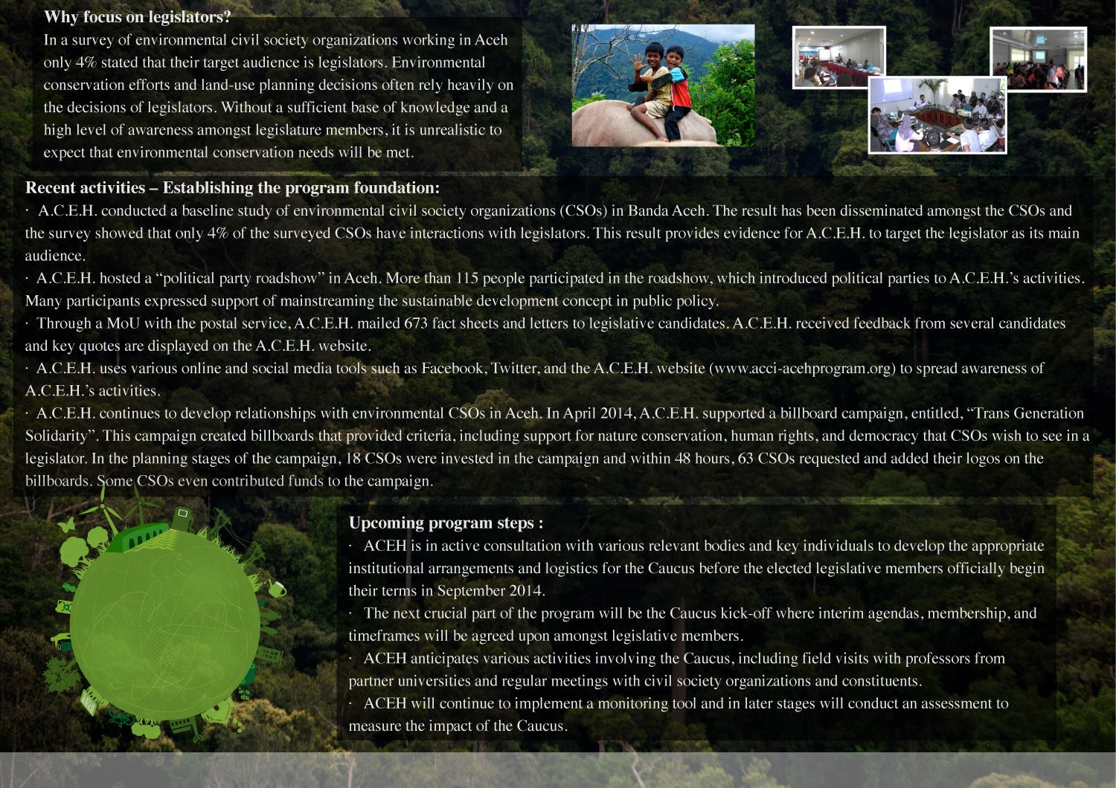
A nstitutional arrangements and logistics fort e Caucus before the elected members of be I

